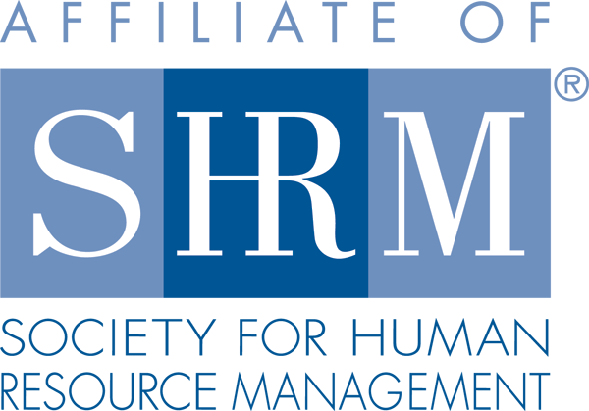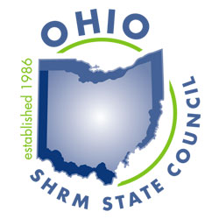

The Ohio SHRM State Council Receives Prestigious SHRM Award
for Advancing the HR Profession

January 25, 2017 — The Society for Human Resource Management (SHRM) recently awarded the Ohio SHRM State Council its prestigious EXCEL Platinum Award for the Council’s accomplishments in 2016.

The award aligns individual chapters and state councils’ activities with SHRM’s aspirations for the HR profession. The award recognizes accomplishments and strategic activities and initiatives that enhance the human resources profession.

“Advancing the human resources profession is a daily mission at SHRM and this STATE Council’s outstanding work this year contributed significantly to that goal,” said Henry G. (Hank) Jackson, president and CEO of SHRM. “Recipients of this prestigious award are those who show a strong commitment to advancing the HR profession through service to the community, local networking, and professional development activities.”

The EXCEL award can be earned at four levels: bronze, silver, gold and platinum, and each level has a prescribed set of requirements and accomplishments that must be met. The Ohio SHRM State Council will receive recognition in SHRM publications and at conferences, a logo to display on their website and information to share with their members about the significance of this award.

One of the Council’s initiatives that we accomplished was the Ohio SHRM State Council partnered with Aspect Marketing and Communications, Inc. for the first ever HR Conference Cruise. We had 40 attendees “Cruise for Credits” from all over the country – including Ohio, Alaska, Illinois, New York, CT, and MD. Our goal was to provide a structured educational process throughout the week, networking opportunities, and also some time for fun! The HR Conference Cruise was pre-approved for 13.75 recertification credits from HRCI and for 12.75 SHRM Professional Development Credits for the SHRM-CP or SHRM-SCP. The conference was also pre-approved for a 8.75 business credits!

For more information about the Ohio SHRM State Council visit ohshrm.org.

About the Ohio SHRM State Council

The Ohio SHRM State Council is a non-profit organization and an affiliate of The Society for Human Resource Management (SHRM), the world's largest HR Professional society with over 285,000 members in more than 165 countries. Our membership is made up of volunteer leaders who are elected or appointed to The Council and includes 25 Chapter Presidents of our local SHRM affiliated chapters in Ohio. The Ohio SHRM State Council is dedicated to leading, educating, and inspiring over 12,000 HR professionals in Ohio. We also serve to make an impact in our local communities by giving back and making HR visible by participating in activities such as workforce readiness and getting involved in the legislative process by making our voices heard as part of our local delegation to our stated and federal lawmakers. Visit us at ohioshrm.org and follow us on Twitter @OHSHRM

About the Society for Human Resource Management

The Society for Human Resource Management (SHRM) is the world’s largest HR professional society, representing 285,000 members in more than 165 countries. For nearly seven decades, the Society has been the leading provider of resources serving the needs of HR professionals and advancing the practice of human resource management. SHRM has more than 575 affiliated chapters within the United States and subsidiary offices in China, India and United Arab Emirates. Visit us at shrm.org and follow us on Twitter and Instagram @SHRMPress.

